 | 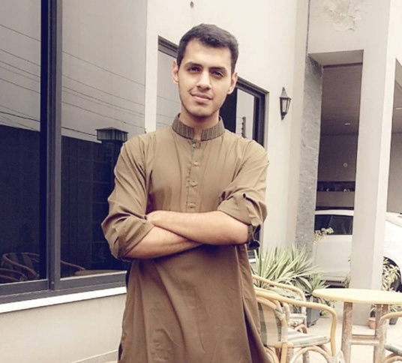  6/1 H3  Wapda Town  Lahore  +92 3224957010  abdulhadiaamir25@gmail.com | Abdul Hadi Aamir  |Web Dev| App Dev | UI/UX | |Freelancer|  What you should know  The trustworthy project hand you can rely on. I exhibit extreme passion for working with Web projects as my experience in the related fields of expertise spans duration of 3 years now. I’m committed to undertaking projects that speak to technology competence and know-how abilities. I specialize in making Android applications as well. All part of my freelance routine.
 | Objective  “Work to learn and never to earn.” | Work Experience  Education  Bachelors in Computer Science (BSCS)  O and A levels in Sciences, Math and IT.
  2015-2016 | July 2018 | June 2018
  Eveloping Lab | Synergy Soft International | TechHub Connect
  A personal online consultancy that provides IT solutions in graphics, web technologies and social media marketing. | My internship with this software house allowed me to grab hands on the .Net framework along with some assistance in Web Designing. | A one month internship at Arfa Tower where it allowed me to work alongside extremely talented and passionate freelancers across the country
  2015-2019 | National University of Sciences and Technology
  2010-2015 | Lahore Grammar School
Skills

HTML/CSS/JavaScript
WordPress
Magento
PHP/SQL/JSON
Photoshop/Illustrator/Adobe XD
Android Studio/JDK
ASP.NET (MVC)/C#
Angular JS/JQuery

 | Online Courses  The Complete Web Developer in 2018 Zero to Mastery  The Complete ASP.NET MVC 5 Course  The Complete Android Lollipop Development Course | The Freelance Occupation  I started working as a part-time freelancer on Fiverr and Upwork in my 5th Semester. The area of expertise is in Web Development and Design. I have worked on several Static & E-commerce domains as well as design projects for various applications. I was also part of the organizing committee of a Freelance Seminar which was hosted at Arfa IT Tower in June 2018.
 | UIUX design with Adobe XD Design & Prototype a Mobile App  Angular (Full App) with Angular Material, Angularfire & NgRx  PHP with MySQL Essential Training | Developer Journey  As a CS major, I have learned to work in a team alongside experienced developers on several projects which include both academic and external ones. With Synergy Soft International, I learned to work on the .Net framework to build fast and secure Apps with JSON/SQL integration. Moreover, I have grasp on Adobe XD which I use for Wireframing and design rendering of apps and websites. I worked on 4 websites for Toyota Pakistan. Alongside countless others for international clients.  Final Year Project  My FYP is based on a three-member group undertaking the task of developing a campus app and portal that has the functionality of connecting nearby student-tutors for academic purposes. Moreover, it allows you to buy or sell items/books or share resources within campus so that your peers can benefit from them. The project has been backed up by top two faculty members of SEECS-NUST.  Other tech interests  - Ran a tech blog. (abdulhadi25.wordpress.com)  - Columnist for 'Solaris' (a science journal)  - Conducted workshop that dealt ethical hacking.  - Skilled in MS Office, Dream Weaver, Photoshop,  Prezi.
The Complete 2018 Fullstack Web Developer Course

Workflow of Modern Web Design from Wireframes to Style Guide

Master (SEO) Search Engine Optimization


www.linkedin.com/in/abdul-hadi-aamir-05b440a9/

www.behance.net/abdulhadiaab8e

